ASSIGNMENT 2

TEAM ID :PNT2022TMID04331

Diag 1:

Task 1:Sales By Customer.

Task 2:Sales By Location.

Task 3:Sales By Sales Representative.

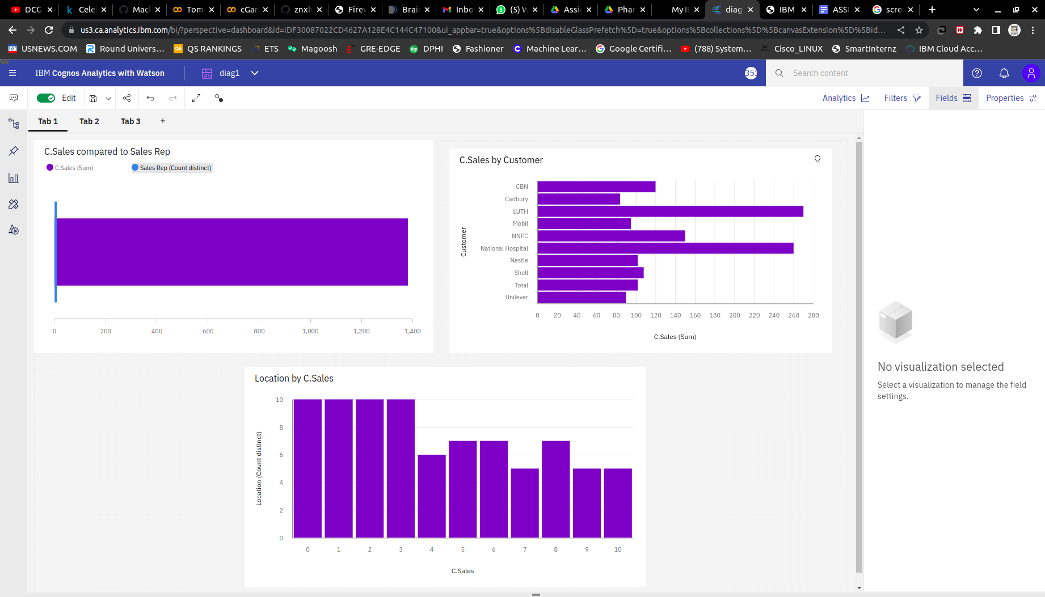

<https://us3.ca.analytics.ibm.com/bi/?perspective=dashboard&pathRef=.my_folders%2FAssignment2%2Fdiag1&action=view&mode=dashboard&subView=model000001838514a057_00000000>

Diag2:

Task 4: Received Inventory From Supplier

Task 5: Inventory Stock for Warehouse Locations

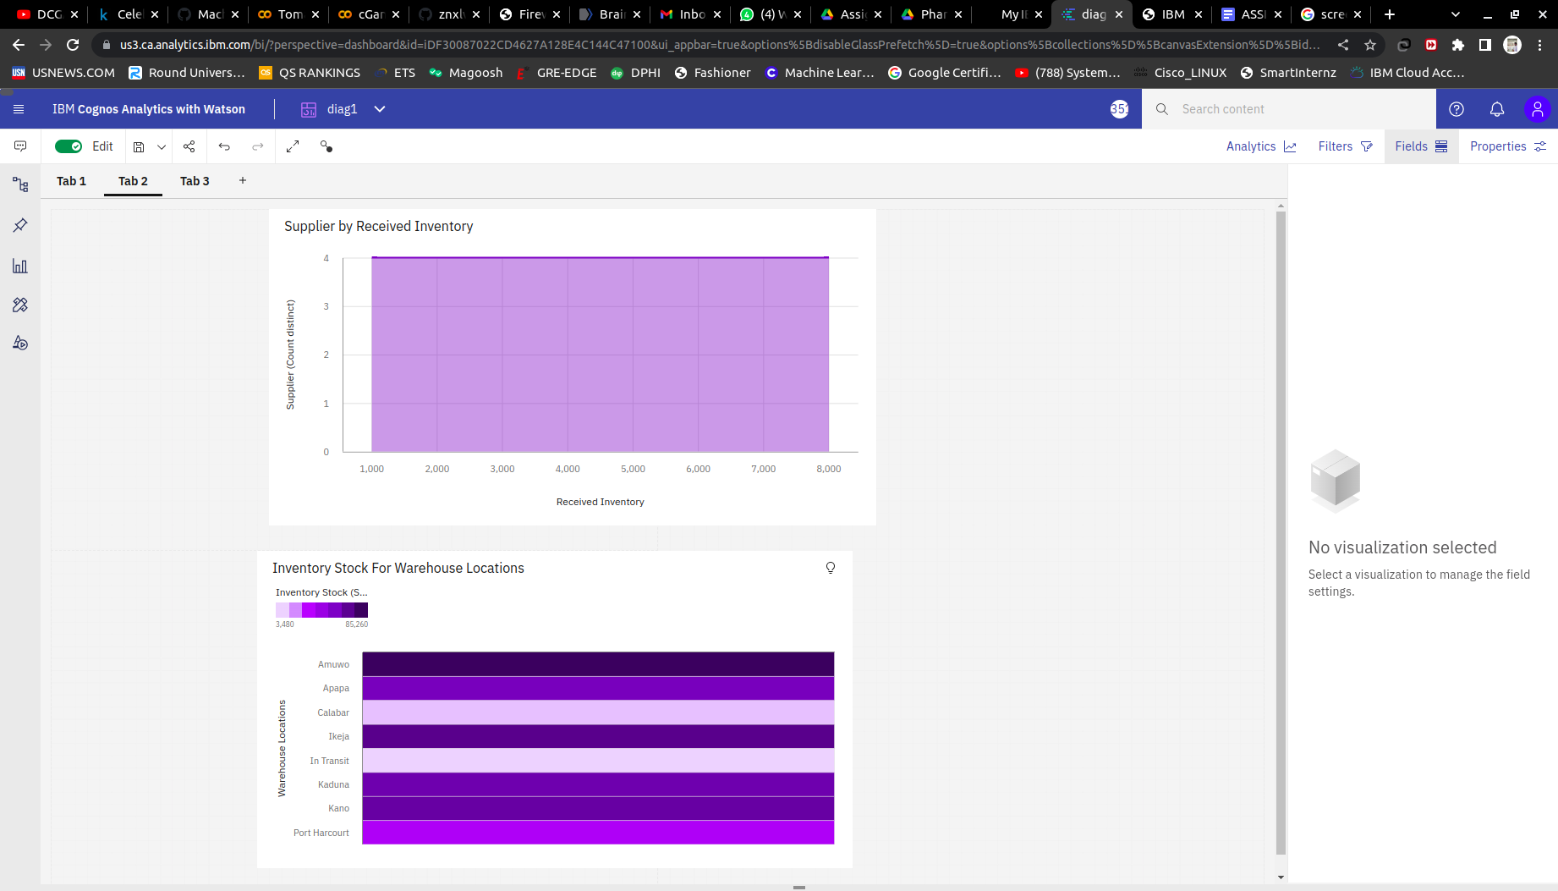

<https://us3.ca.analytics.ibm.com/bi/?perspective=dashboard&pathRef=.my_folders%2FAssignment2%2Fdiag1&action=view&mode=dashboard&subView=model000001838514a057_00000000>

Diag3:

Task 6: Sales Trend

Task 7:Monthly Sales

Task 8: Actual and Received Inventory by Month

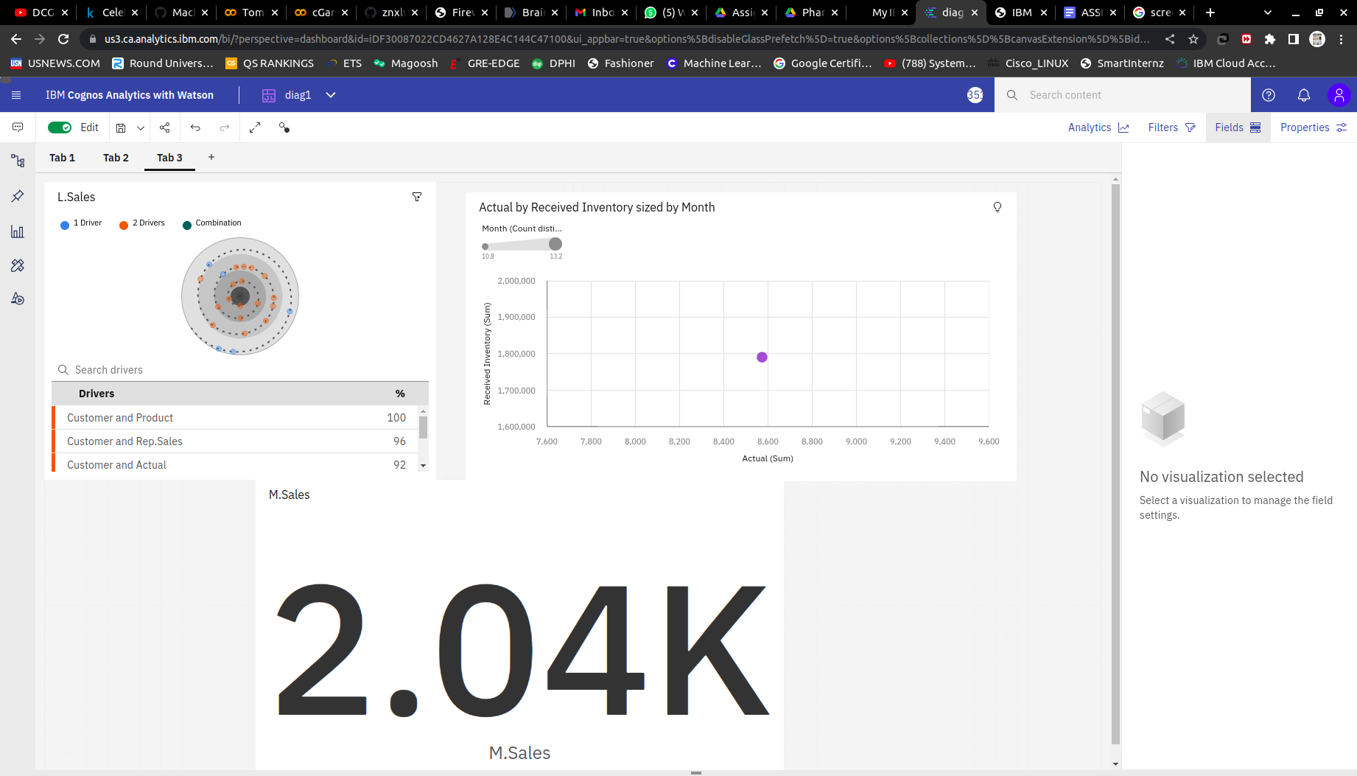

<https://us3.ca.analytics.ibm.com/bi/?perspective=dashboard&pathRef=.my_folders%2FAssignment2%2Fdiag1&action=view&mode=dashboard&subView=model000001838514a057_00000000>